Noughts & Crosses



In this project you will create a noughts and crosses game in Python that is able to learn from how you play.

You won’t give it instructions for how to play, or tell it what the objective or rules of the game are.

Instead, you’ll show it examples of you playing the game. When it’s seen enough examples to start trying to play for itself, you’ll tell when it beats you.

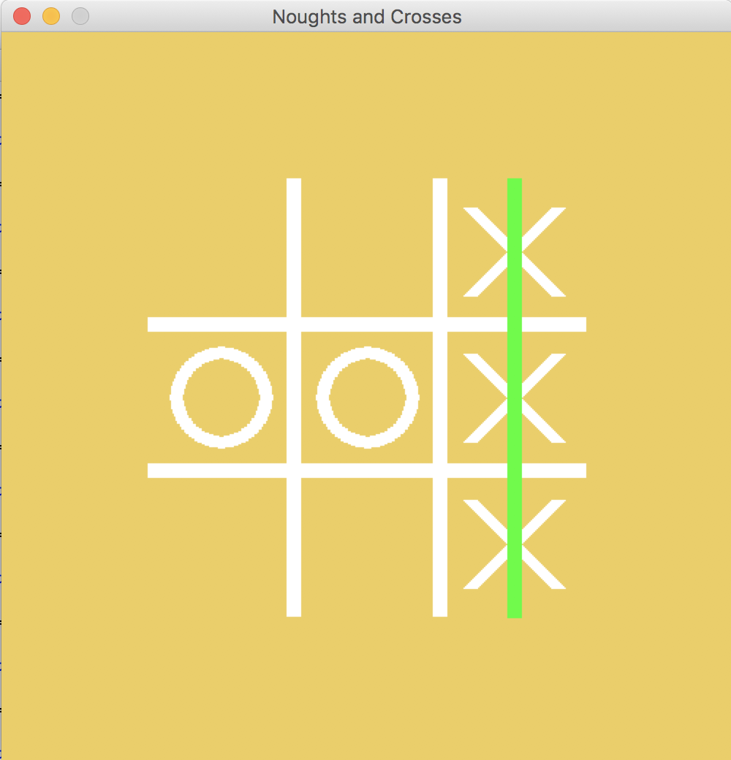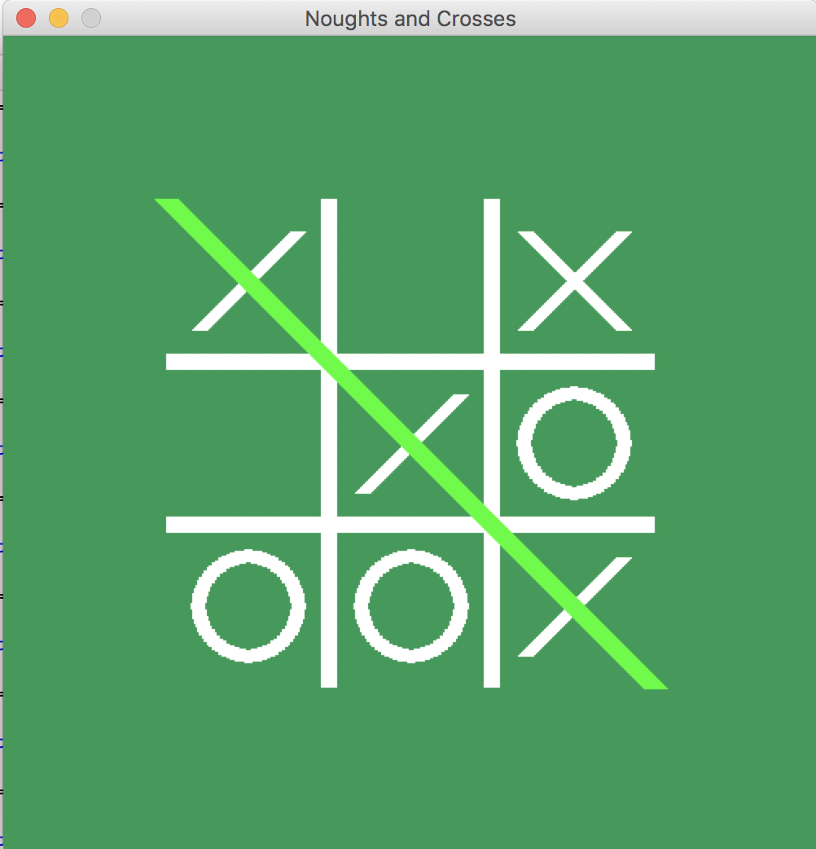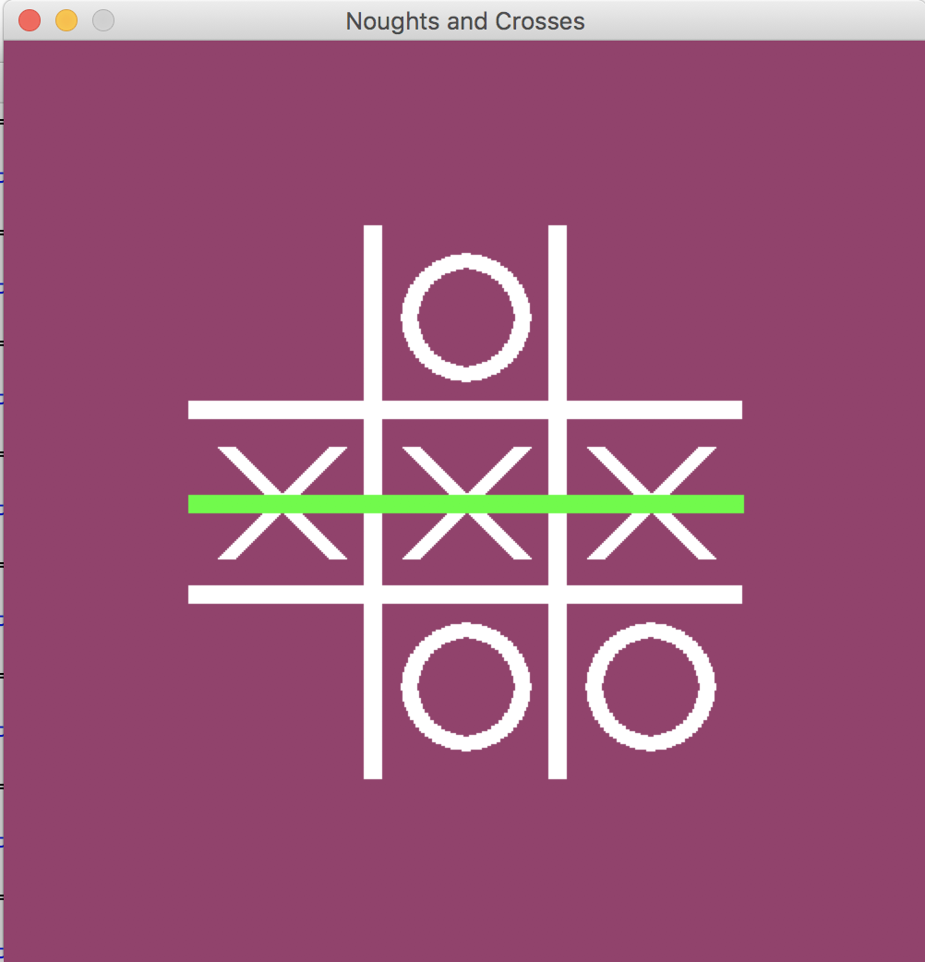

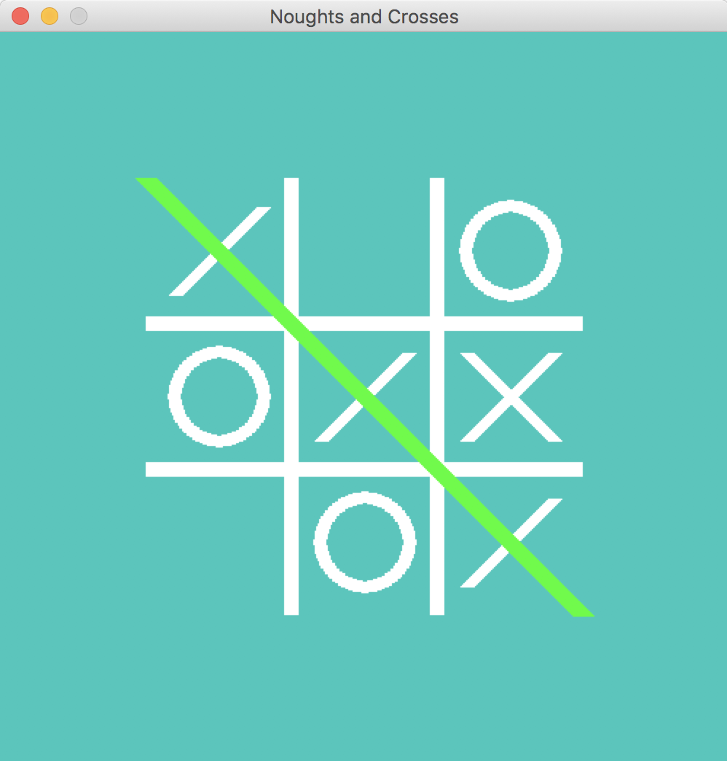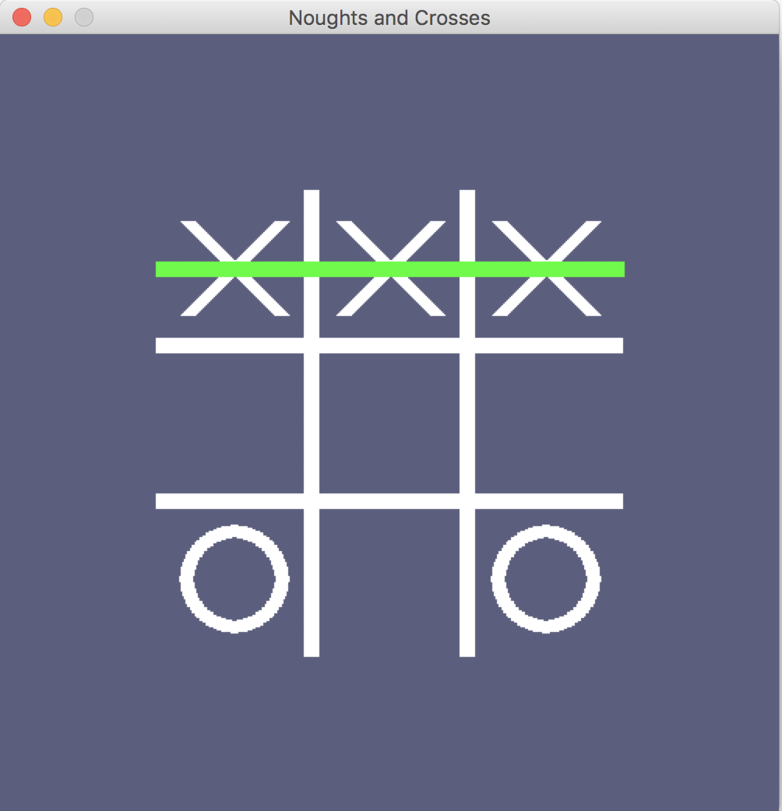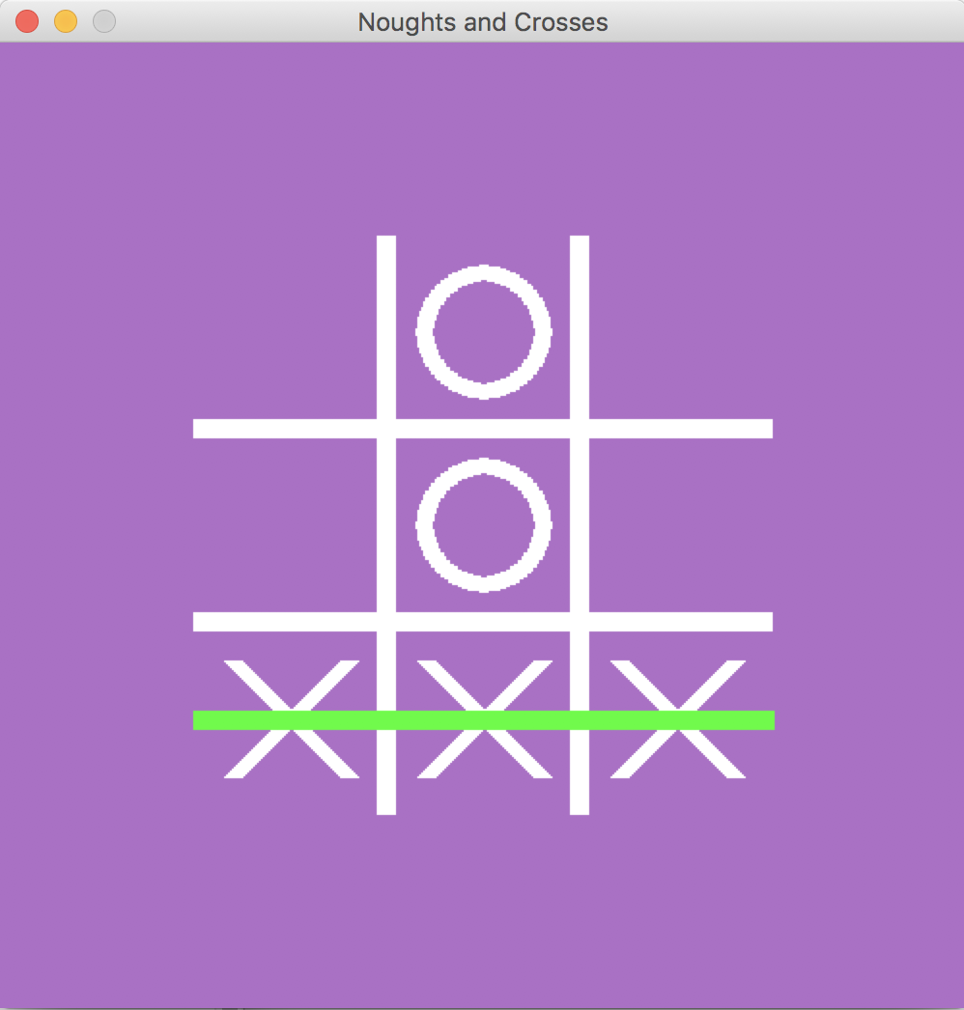

This project worksheet is licensed under a Creative Commons Attribution Non-Commercial Share-Alike License

http://creativecommons.org/licenses/by-nc-sa/4.0/

Representing noughts and crosses in Python

0

The positions of spaces on the noughts and crosses board are numbered from 0 to 8.

They are then stored in a list.

2

1

0 1 2 3 4 5 6 7 8

[1, 1, 1, 1, 1, 1, 1, 1, 1]

The board is represented as a list of 9 1’s, 2’s and 3’s, one for each space

For example, at this point:

[2, 1, 1, 1, 3, 1, 1, 1, 1]

An empty space is shown as a 1.

A nought O is shown as a 2.

A cross X is shown as a 3.

.

X

O

Empty = 1

O = 2

X = 3

8

7

6

5

4

3

**What are you going to do?**

You’re going to train a computer to play noughts and crosses. You’ll do this by showing it examples of how you play the game.

Imagine the board looks like this and it’s O’s turn.

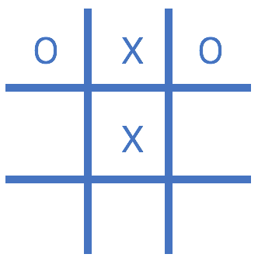

Imagine you decide to put your O in

the bottom middle space.

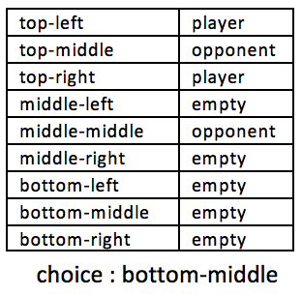

Imagine the board looks like this and it’s X’s turn.

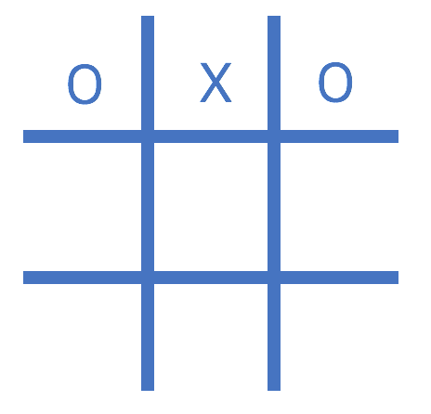

Imagine you decide to put your X in

the centre space.

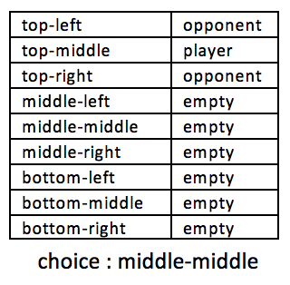

Using “opponent” and “player” instead of “nought” and “cross” means the computer can learn from both nought and cross moves.

You’ll use examples of moves from the player that wins the game to train the computer.

If you (X) win, you’ll use your moves as examples to train the computer.

If the computer (O) wins, you’ll use the computer’s moves to train with.

These **examples of moves that lead to winning** will teach the computer how to play to win!

1. Go to <https://machinelearningforkids.co.uk> in a browser.
2. Click on “**Get started**”
3. Click on “**Log In**” and type in your username and password  
   *If you don’t have a username, ask your teacher to create one for you.  
   If you can’t remember your password, ask your teacher to reset it for you.*
4. Click on “**Projects**” on the top menu bar
5. Click on the **“Copy template**” button.  
   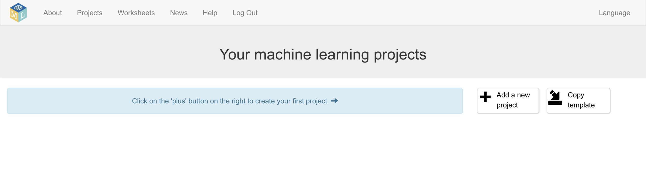
6. Import the “**Noughts and Crosses**” project template.   
   *Make sure that you select the option to store it in the* ***cloud****.*
7. You should see “**Noughts and Crosses**” in your list of projects.   
   Click on it.  
   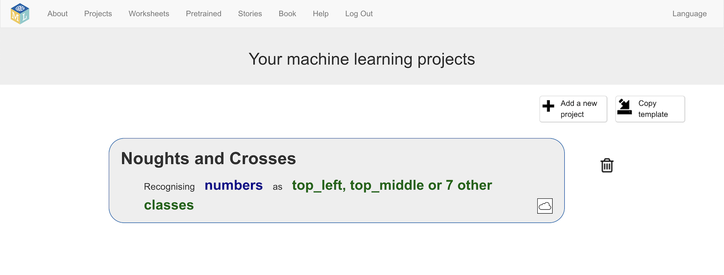
8. Click the “**Train**” button  
   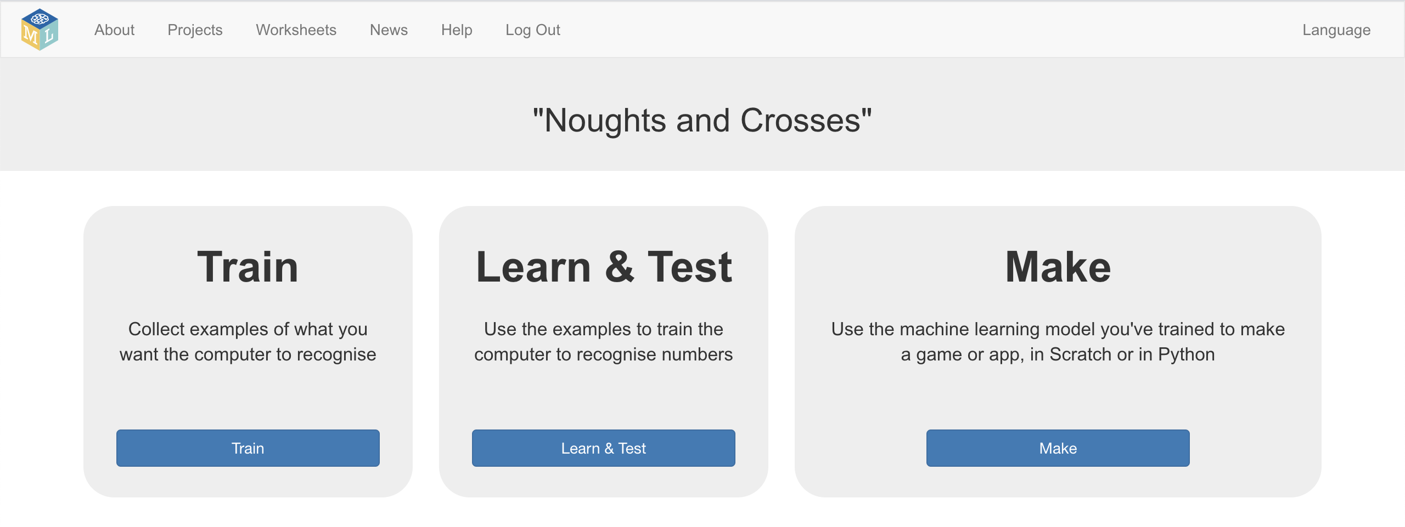
9. The template project has training buckets to store examples of noughts and crosses game moves. 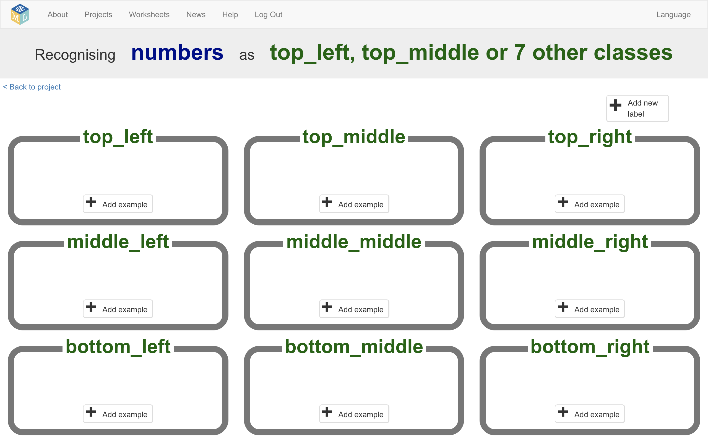
10. Click the “**< Back to project**” link.
11. Click on “**Make**”

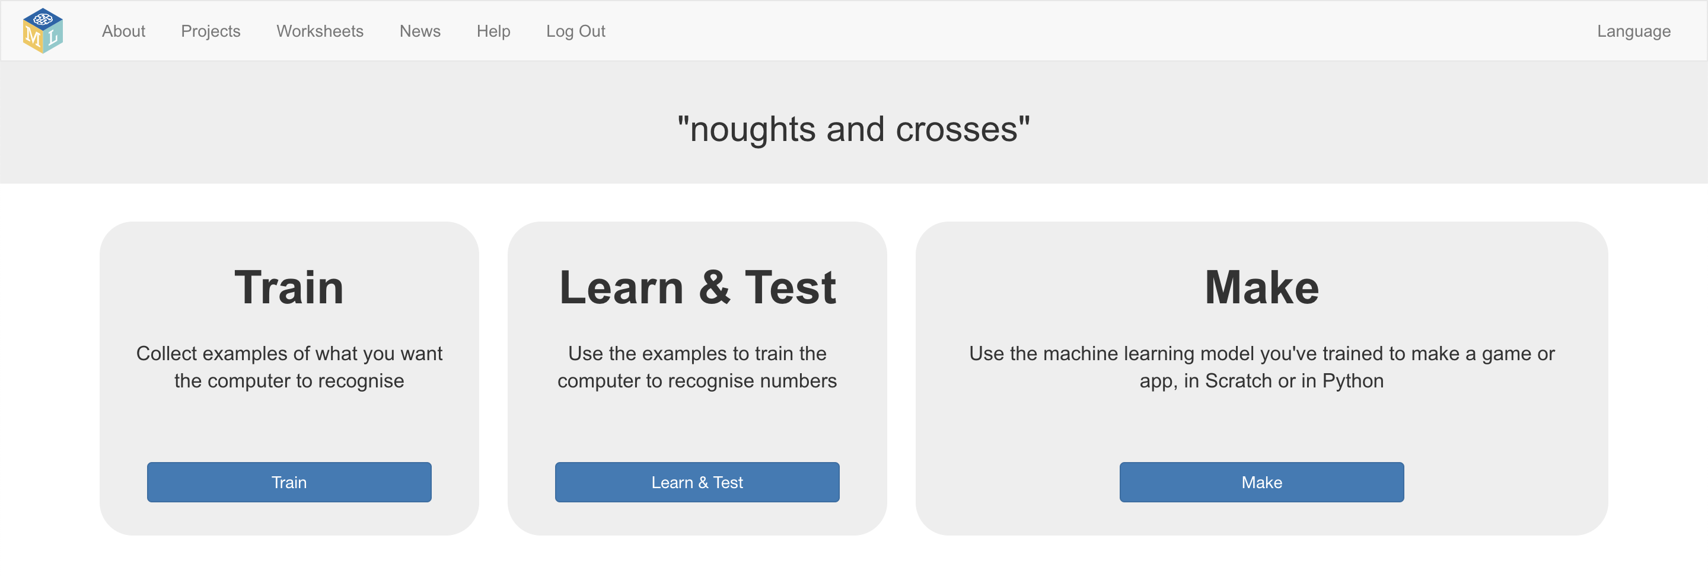

1. Click on “**Python**”
2. Find your project “key” in the sample code. You’ll need this later.   
   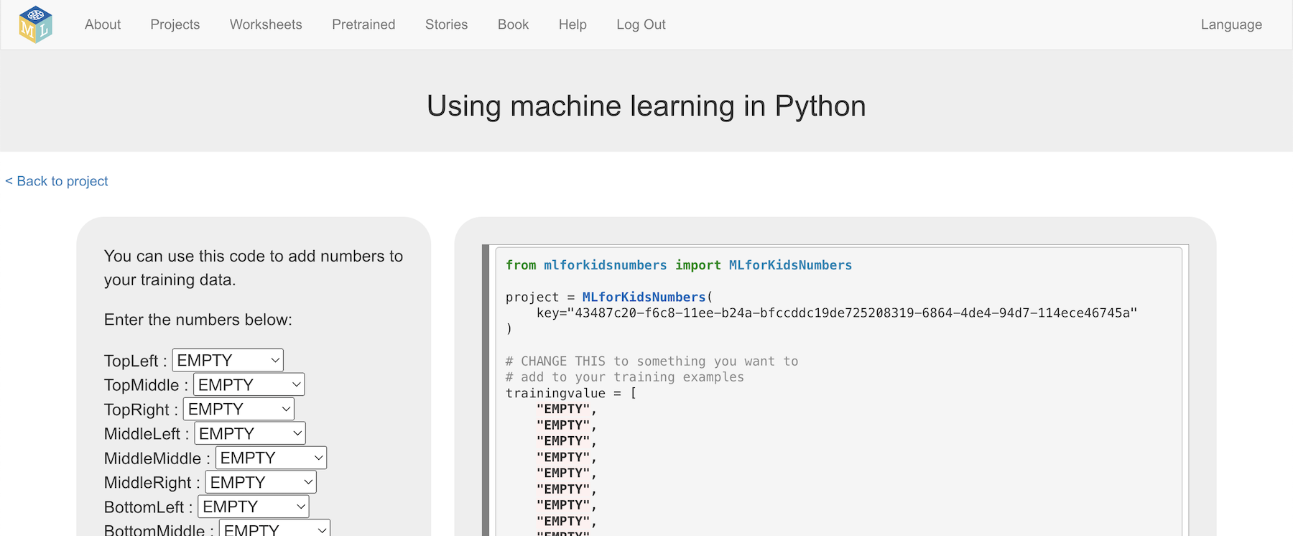
3. **Visit** <https://github.com/dalelane/Noughts-and-Crosses>
4. Click the “**Clone or download**”button, then click “**Download ZIP**”

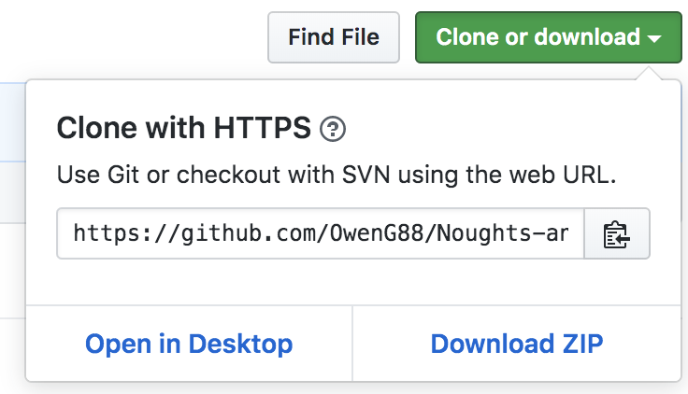

1. Unpack the ZIP and open the Python code in your preferred editor.
2. Update the project variable using the sample code from Step 13  
   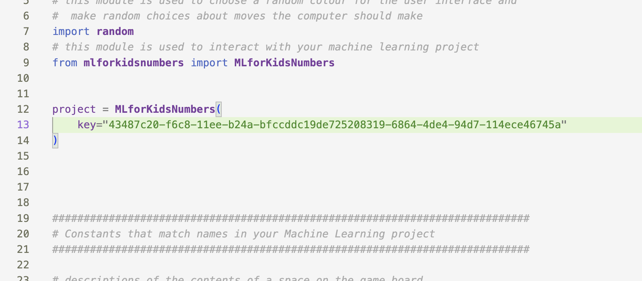
3. Install the requirements listed in requirements.txt   
   Ask your teacher if you need help with this.
4. Run the Python program.   
   Play a game of noughts and crosses against the computer.  
     
   Your machine learning project will be choosing where to make it’s moves at random.
5. Look at the output from the Python program after the game ends.  
   *Next, you will edit the Python program so that the moves made by whoever wins the game are used to train your machine learning model.*

HUMAN won the game!  
Maybe the computer could learn from HUMAN's experience?  
  
At the start of move 1 the board looked like this:  
['EMPTY', 'EMPTY', 'EMPTY', 'EMPTY', 'EMPTY', 'EMPTY', 'EMPTY', 'EMPTY', 'EMPTY']  
And HUMAN decided to put their mark in bottom_left  
  
At the start of move 2 the board looked like this:  
['COMPUTER', 'EMPTY', 'EMPTY', 'EMPTY', 'EMPTY', 'EMPTY', 'HUMAN', 'EMPTY', 'EMPTY']  
And HUMAN decided to put their mark in middle_middle  
  
At the start of move 3 the board looked like this:  
['COMPUTER', 'EMPTY', 'EMPTY', 'EMPTY', 'HUMAN', 'EMPTY', 'HUMAN', 'EMPTY', 'COMPUTER']  
And HUMAN decided to put their mark in top_right

1. Find the **learn_from_this** function  
   *It is printing out the moves made by whoever won the game.*  
   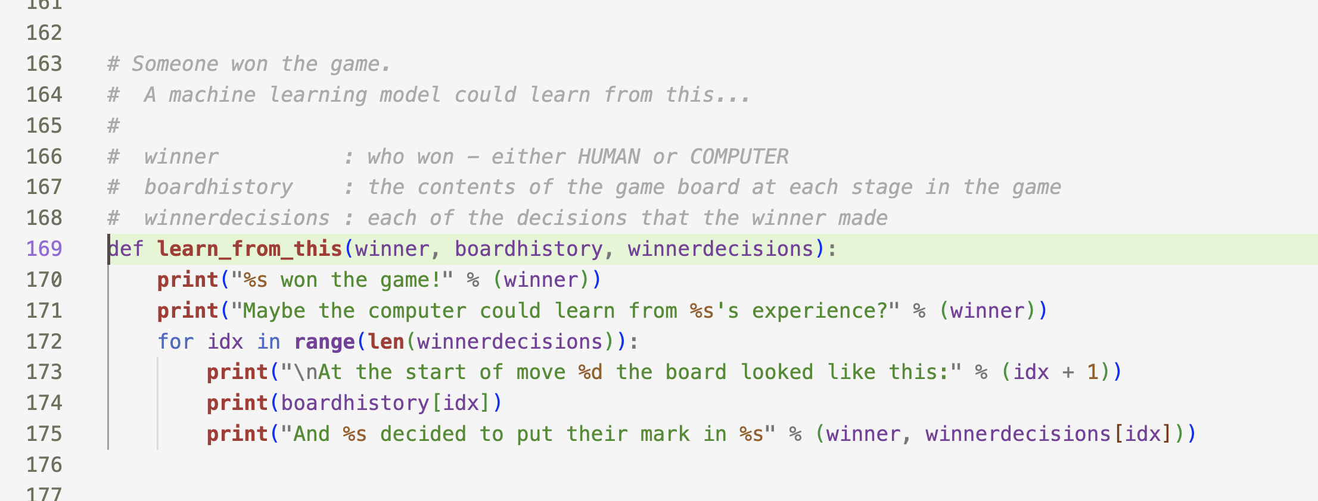
2. Add a line in the for loop so each move is added to your project training data  
   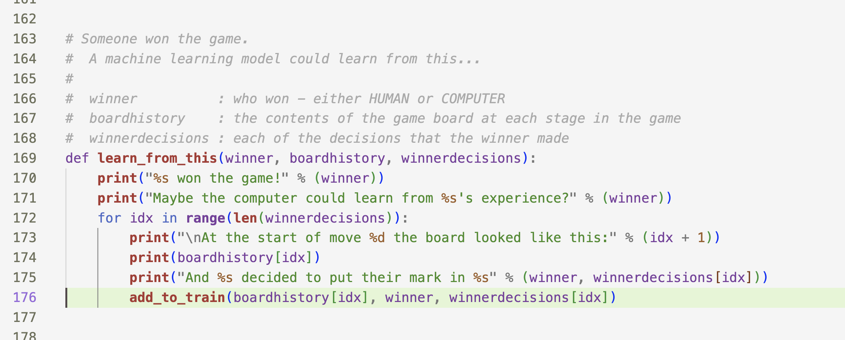
3. Run your Python program again and play another game.
4. Go back to the training page  
   *Leave the Python window to go back to the training tool window.   
   Click the “****< Back to project****” link and then click “****Train****”  
   *
5. Look at your training so far  
   *Each item is a move made by the winning player.   
   The details in each item describe the state of the board at the time the winning player made that move.   
   This is collecting training data, but you still need to use it to train a machine learning model.*
6. Go to the Learn & Test page  
   *Click the “****< Back to project****” link and then click “****Learn & Test****”  
   You will see that you don’t have enough examples to train a machine learning model yet.*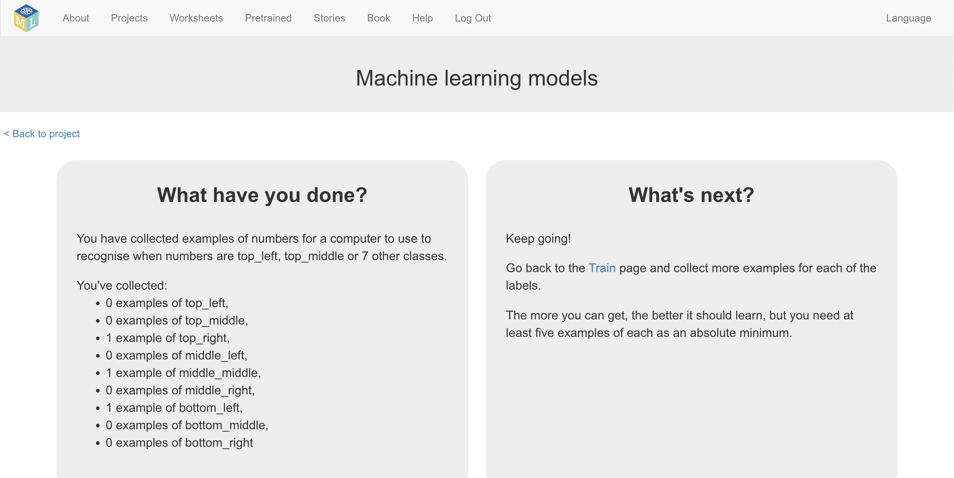
7. Play several more games.  
   *Your changes to the code mean that after every game finishes, the moves made by the winner are added to the training data as examples of how to win, and a new model is trained using all examples collected so far.   
   The longer you play, the more the computer can learn from you, and the better it should get.*

1. Go back to Learn & Test page and refresh it  
   *Do you have enough examples to train a model yet?   
   If no, go back to step 27 – play more games   
   If yes, you can go on to step 29*
2. Train a new machine learning model with the example games you’ve collected so far  
   *Click on the* **Train new machine learning model** *button*   
   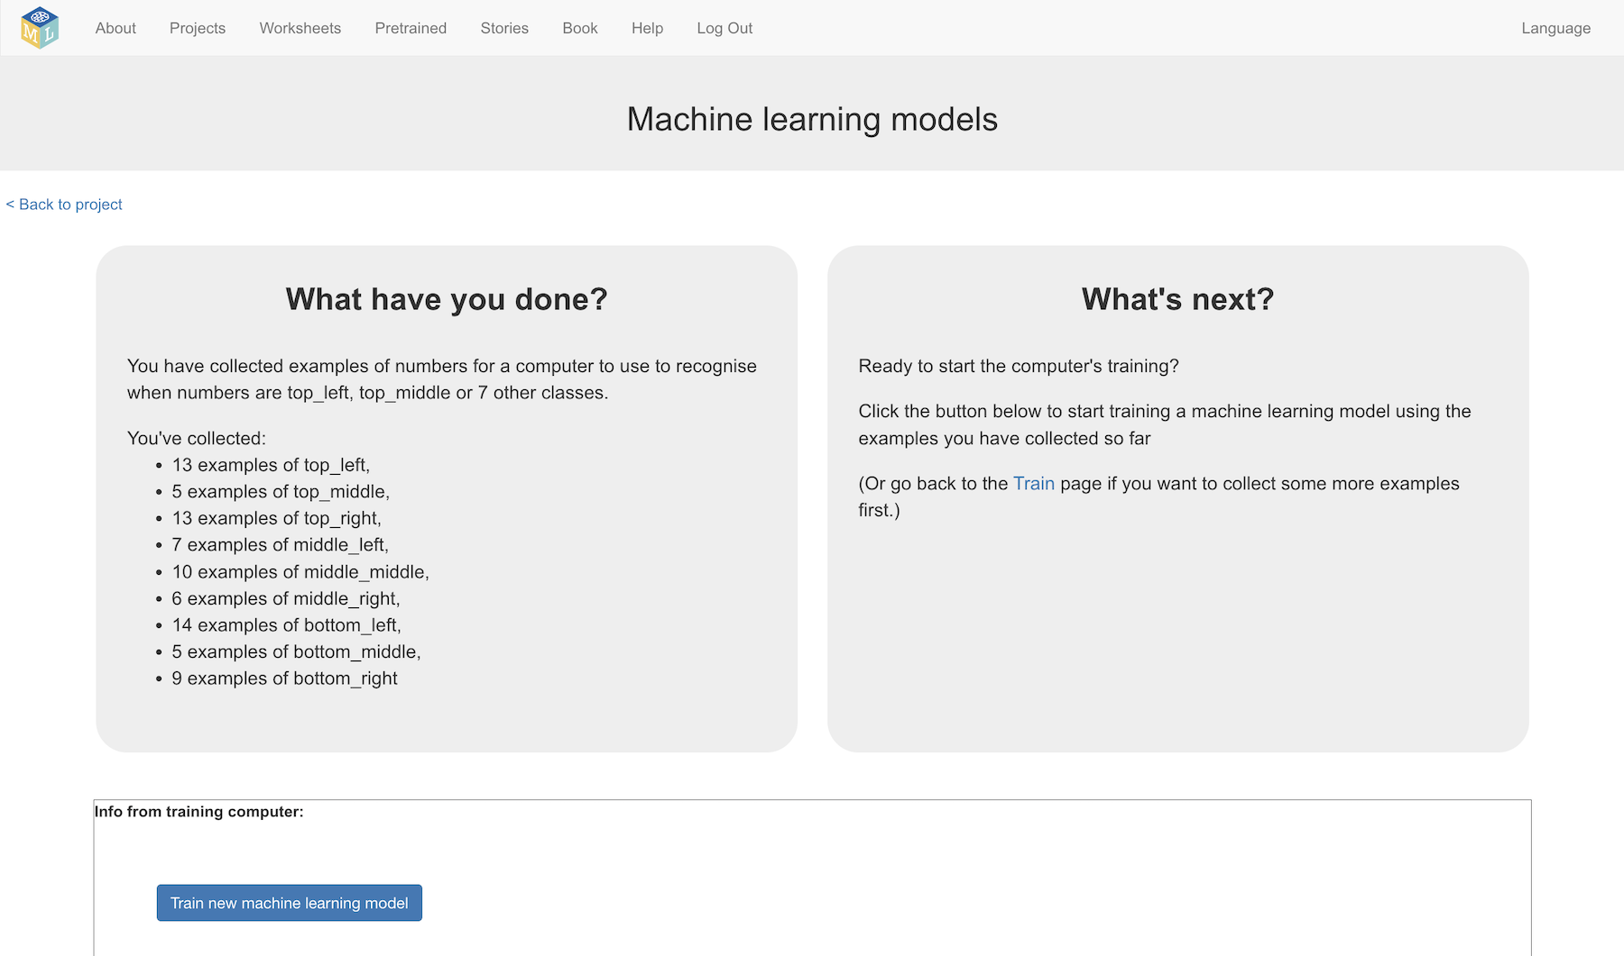
3. Once your model is trained, go back to the **Python** page  
   *Click the “****< Back to project****” link, then click “****Make****”, then “****Python****”  
     
   You should see that now you have a model, the sample code has been updated to include the web address of your machine learning model*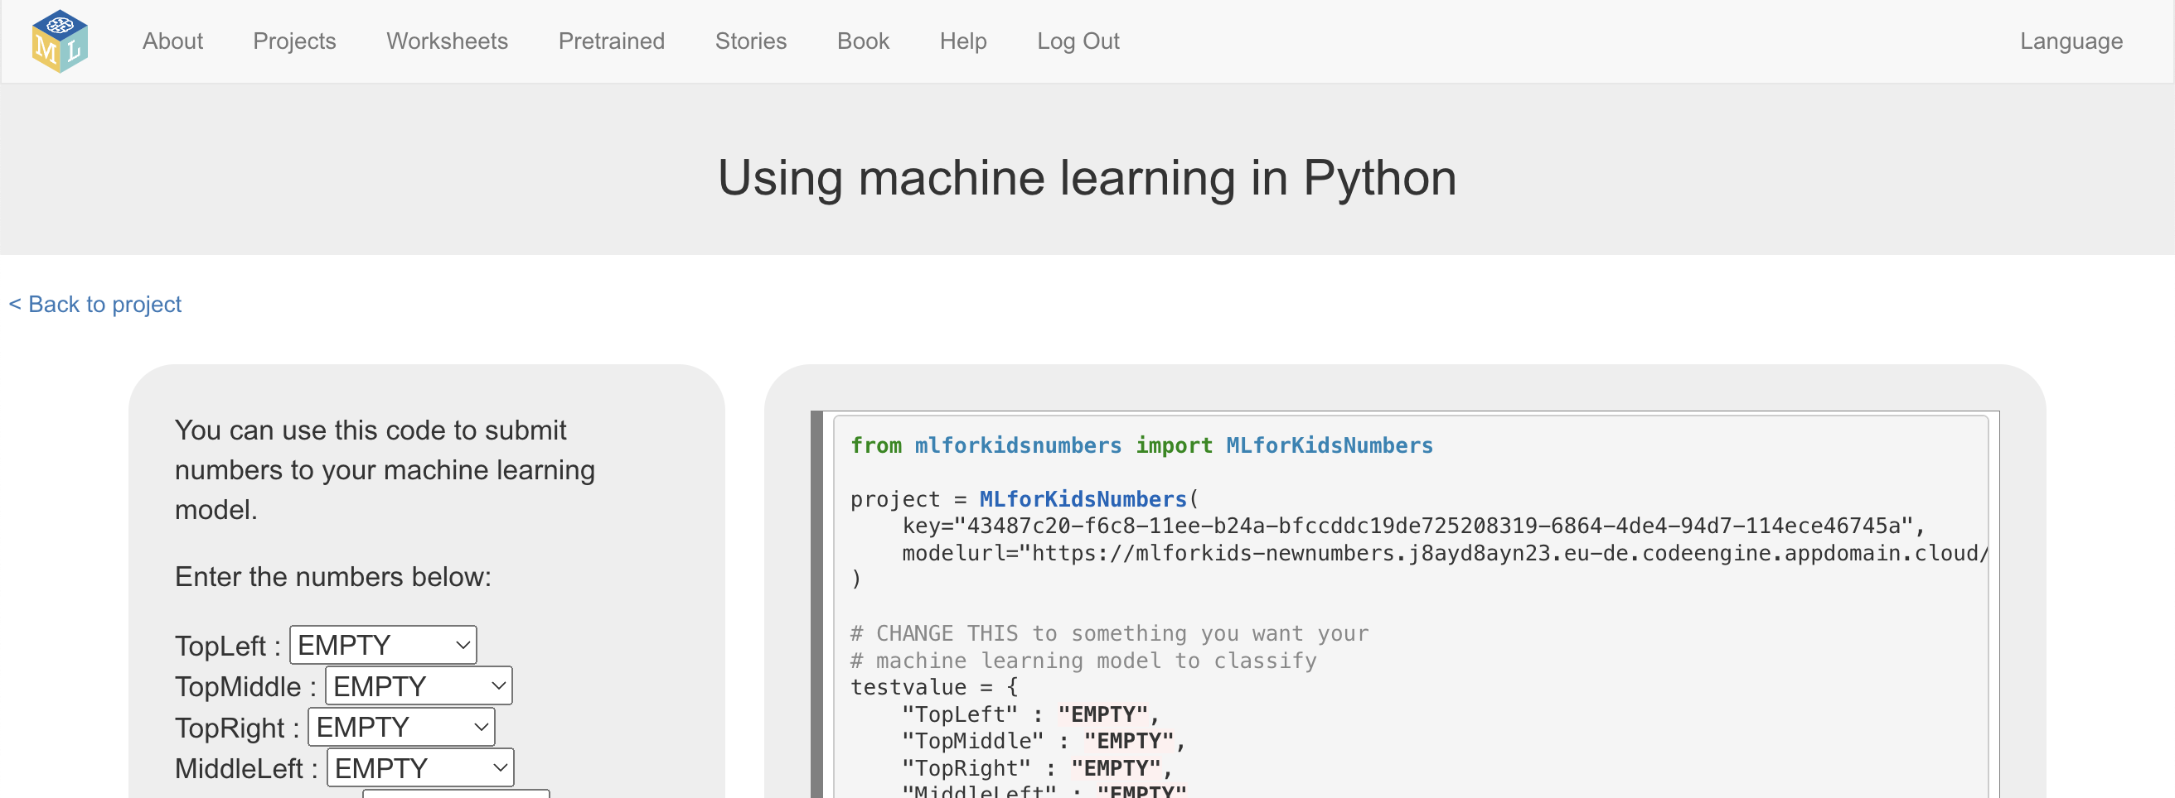
4. Update the project variable in your code to match   
   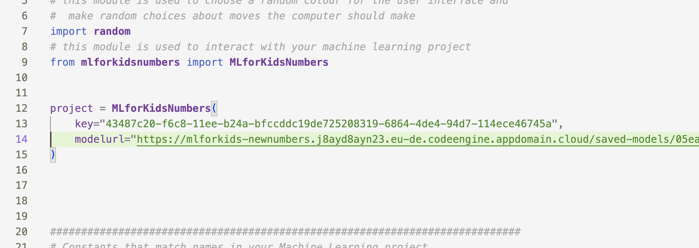
5. Run the Python program again, and play more games of   
   Noughts and Crosses.   
   *Now that you have a machine learning model, the computer will be using this to decide on where to move, instead of choosing at random*

*As you play, the winning moves from every game are still being added to your training examples. You are collecting more examples of games that will help your project to learn to be better at playing the game.*

1. After playing several more games, go back to the **Learn and Test** pageto train a new model  
   *Click the “****< Back to project****” link, then click “****Learn and Test****”*
2. Click the **Train new machine learning model** button
3. Find the directory where your Python project is, and then   
   delete the saved-models folder  
   *Your Python code downloads the machine learning model from the Machine Learning for Kids server. Deleting your local copy will get it to download the new updated model*
4. Run the Python program and play again against the updated model   
   *Has the extra training improved the way it plays the game?*

**What have you done?**

You’ve trained a computer to play noughts and crosses.

You didn’t have to describe the rules to the computer.

You didn’t tell it that it should try to get three noughts in a row.

(The rules are in the Python code so it can be displayed but aren’t used in the machine learning model).

You showed it how you play, by collecting examples of decisions that you made when you win. When it makes decisions that leads to it winning, this is added to its training data, so it can be even more confident in that approach in future.

**Tips**

**Don’t be kind!**

You might be tempted to go easy on the computer when you’re playing against it, particularly when it’s just starting to learn and is playing very badly.

For example, you might have two crosses-in-a-row next to a blank space and could win. But instead, you might feel sorry for it doing badly and put a cross somewhere else instead to give it a chance.

Don’t.

It is learning from the way that you play. If you don’t complete a three-in-a-row when you can, you will be teaching it that it should do that.

If you want it to get better quickly, **play as well as you can**.

**Mix things up with your examples**

Try to come up with lots of different types of examples.

For example, start from a different position on the board on every turn.

**Did you know?**

People have been learning about machine learning by training a computer to play noughts and crosses for decades!

One famous example was **Donald Michie** – a British artificial intelligence researcher. During World War II, Michie worked at Bletchley Park as a code breaker.

In 1960, he developed “**MENACE**” – the Machine Educable Noughts And Crosses Engine. This was one of the first programs able to learn how to play noughts and crosses perfectly.

As he didn’t have a computer he could use, Michie built MENACE using 304 matchboxes and coloured glass beads.

Each matchbox represented a possible state of the board – like the examples that you’ve been collecting in your training data.

He put beads in the matchboxes to show how often a choice led to a win – the number of beads in the matchbox was like the number of times an example shows up in one of the buckets you created for your training data.

